  w | National University  of Computer and Emerging Sciences  Chiniot-Faisalabad Campus  Department of Artificial Intelligence and Data Science | 

Name: Qamar Abbas

Roll No: 23F0027

Subject: NLP Assignment 2 Report

Date:05– 04- 2026

Title

“Word Embeddings and Representation Learning”

Module 1: Frequency-Based Embeddings
In this module, Bag of Words (BoW) and TF-IDF techniques were implemented. Text data was preprocessed using tokenization, stopword removal, and lowercasing. Logistic Regression was used for classification.
TF-IDF performed better than BoW as it assigns importance to words based on frequency across documents. However, these methods suffer from major limitations such as lack of context awareness and inability to capture semantic relationships. Words are treated independently, and word order is ignored.
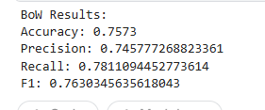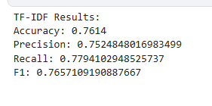
Module 2: Prediction-Based Embeddings
This module used Word2Vec and GloVe embeddings. Word2Vec was trained on the dataset, while GloVe used pretrained vectors. Sentence embeddings were generated by averaging word vectors and fed into a neural network.
Although these embeddings captured semantic similarity (e.g., “good” and “great”), performance was lower than TF-IDF in some cases. This is because averaging word vectors leads to loss of contextual and positional information. Additionally, these embeddings are static, meaning a word has the same representation in all contexts.
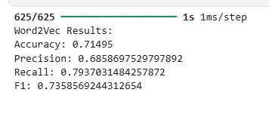
Module 3: Contextualized Embeddings
BERT was used to generate contextual embeddings. Unlike previous methods, BERT produces different embeddings for the same word depending on its context. Sentence embeddings were extracted using the [CLS] token and used with Logistic Regression.
This approach achieved the highest accuracy. A polysemy test using the word “bank” showed different embeddings for financial and river contexts, demonstrating BERT’s contextual understanding.
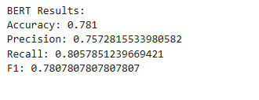
Final Comparison
Module | Technique | Accuracy | Key Observation
Module 1 | TF-IDF | ~76% | No context, but strong for keywords
Module 2 | Word2Vec / GloVe | ~70–72% | Captures semantics, loses context
Module 3 | BERT | ~78% | Context-aware, best performance
Final Analysis
Best Model:
BERT performed the best due to its ability to understand context and word meaning dynamically.
Why:
Unlike TF-IDF and Word2Vec, BERT considers the position and surrounding words, allowing it to capture deeper linguistic patterns.
Trade-offs:
Model | Advantage | Disadvantage
TF-IDF | Simple, fast | No semantics
Word2Vec/GloVe | Semantic similarity | No context awareness
BERT | High accuracy, contextual | Computationally expensive

